Code Challenge : 8

Time : 70 mts

1. Write a JavaScript program to calculate multiplication and division of two numbers (input from user).

Sample Form:

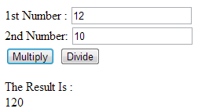

1. Write a JavaScript for loop that will iterate from 0 to 15. For each iteration, it will check if the current number is odd or even, and display a message to the screen.

Sample Output :

"0 is even"  
"1 is odd"  
"2 is even"

1. Write a JavaScript program that creates a button and add a click event listener to log a message when it's clicked.